Saw Kyaw Khant Lin


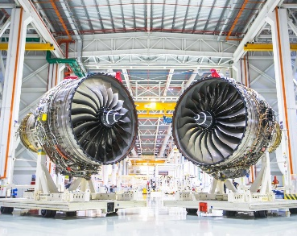
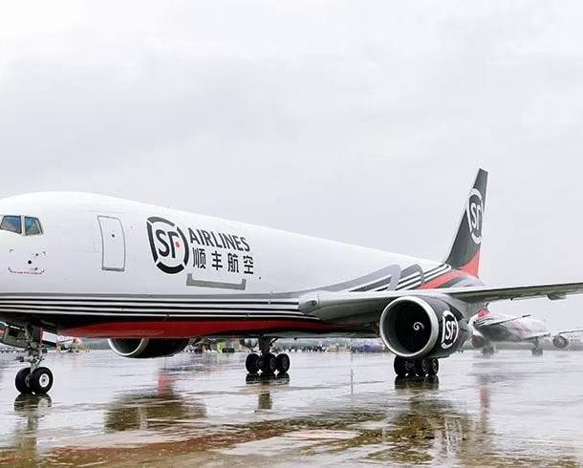
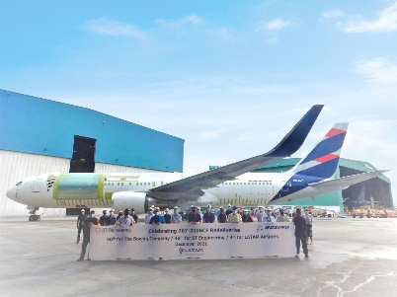
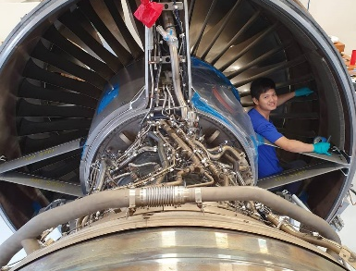
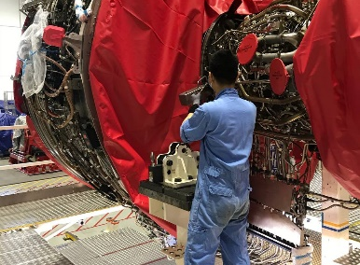
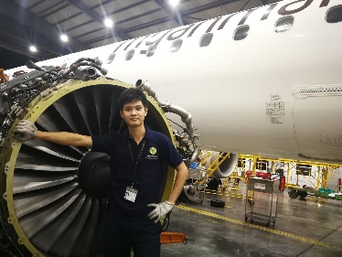
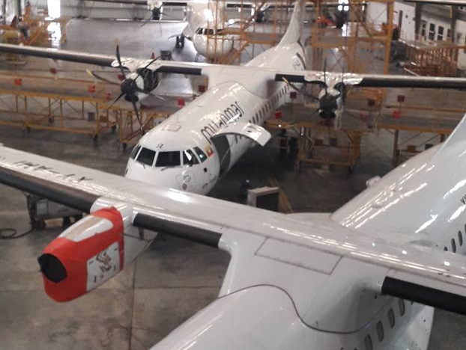
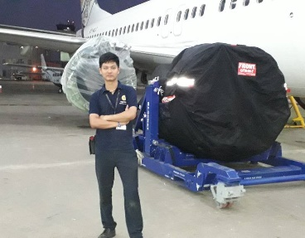
sawkklynn@gmail.com

I am a skilled and seasoned candidate with a proven track record in Aircraft Engine and Aircraft maintenance. Throughout my career, I have consistently demonstrated my competency and loyalty to my employers. I thrive in new environments, readily adapting to change, and eagerly embracing new challenges. My expertise lies in effectively coordinating diverse teams and resources to achieve objectives. With over 5 years of experience in the Aviation industry, I am well-prepared to excel in a fast-paced role.

- Checked stock inventory and raw material not to lack and avoid buildup of high stock
- Liaised with sale team, production department, warehouse to arrange production plan
- Performed material and planning, requisition of material and BOM analysis

Google Workspace
Microsoft Office
Microsoft Project
Basic Accounting
Erp Systems
OGLE WORKSPACE
MICROSOFT WORD Google Workspace
Microsoft Word
Microsoft Excel
Microsoft Project
Basic Accounting
Erp Systems

MICROSOFT EXCEL
MICROSOFT PROJECT
BASIC ACCOUNTING
ERP SYSTEMS

DOB : 31 October 1994
Marital Status : Single
Passport No : G3847669L
Nationality : Myanmar
Availability : Immediately
Expected Salary :SGD3700-4000 (Nego)
Production Planner (Jul 2021 – Sep 2022)
Myanmar Interplast Co.,Ltd. Myanmar

Senior Aircraft Technician (Oct 2022 – Present )
ST Engineering Aerospace Service Co.,Ltd. Singapore
Myanmar
- Perform C and D heavy maintenance tasks and other tasks requested by LAE
- Inspected and examined aircraft components for leaks, cracks, or defects.
- Read and utilized drawings, AMM, ATA codes, IPC, SB, and other maintenance documents to troubleshoot and complete the work assignments.
- Performed Boeing conversion to Freight (BCF), Passenger to Freight (PTF-Airbus) aircraft for cargo conversion type.
- Read the isometric view drawing to do modification as the aircraft is conversion to cargo aircraft.
- Performed routine maintenance operations, such as R&I of power plant and aircraft component parts.
- Ensured safety rules and regulations are always complied with ST.

1 Simei Street 4, #10-06 S529861

+65 85982326 (WhatsApp)

PROFILE SUMMARY
Bachelor of Aerospace Engineering
(2011 – 2016)
Myanmar Aerospace Engineering
University

Personal Information
Software Skills
Working Experience
Senior Aircraft Technician
Education Background
Rolls Royce Trent 1000 -TEN Engine
B737-800NG Engine Change
ATR 72-212A maintenance
SF Airline BCF
BoeingConversionFreight Project
Strip LPC of Trent 1000 Engine
CFM 34-10E Engine Installation
Trent 1000 Engine Lifting
Photo Reference
- Scheduled shipments for daily charts
- Adjusted timing between shippers and cargo vessels
- Provided Customer service support for cargo storing

Other Certificates
- Project Management Professional Course
Myanmar Project Management Training Center
- Industrial Training Course
Myanmar National Airlines
- Boeing: 737, 767 (BCF), 787, 777
- Airbus: 320 Family, 330 (PTF)
- ATR 72-212A, MD 11, Embraer E190

Aircraft Handled
- Maintenance
- Planning & Organizing
- Strong Engineering
- Mechanical
- Data Analysis
- Communication
- Observation
OGLE WORKSPACE
MICROSOFT WORD Google Workspace
Microsoft Word
Microsoft Excel
Microsoft Project
Basic Accounting
Erp Systems

MICROSOFT EXCEL
MICROSOFT PROJECT
BASIC ACCOUNTING
ERP SYSTEMS

Language
Aircraft Technician (Jun 2017 – Mar 2019)
Myanmar National Airlines Myanmar
(B737-800NG / EMBRAER / ATR72/42/ Cessna)

- Worked as a Mechanic, did the scheduled checks for aircraft
- Troubleshot, diagnosed, and report findings of discrepancies
- Performed DCA annual inspections, after major repair or alterations, certified airworthiness for flight
- Accurately read, understood, and carried out work instructions according to AMM and IPC
- Worked with all aircraft parts including engines, electrical systems, temperature and pressure control system, hydraulic system, communication systems and instrument systems
- Finished work documents according to EASA standard
- Removed and installed of Engines for CFM56-7B, CF34-10E and PW 100 series and aircraft components and other attached components

- Stripped & built the Gas Turbine Engines
- Carried out routine maintenance checks & preventative maintenance program
- Performed engine and module assembly tasks, worked on self-inspection tasks
- Followed the respective zonal inspection such as snag rectification, modification and repairing under the supervision of work team leader
- Read work Instructions to determine inspection and test criteria and procedure.
- Worked at Engine production (SATU) line and read the SAP view to build the Aircraft Engine.
- Ensured the correct use of approved tools and equipment for engine assembly.

Supply Chain Planner (Dec 2016 – Mar 2017)
Damco Logistics Myanmar Myanmar

Burmese : Native
English : Fluent
Aircraft Engine Technician (Mar 2019 – Jun 2020)
Rolls-Royce Singapore Pte Ltd Singapore
(TRENT 1000/ TRENT 7000/ TRENT 900) Gas Turbine Engines

Technical Skills

